**ASSIGNMENT -3**

**T S V V SRIRAM 20R15A0405**

**1)CODE FOR DHT11 – TEMPERATURE AND HUMIDITY SENSOR**

#include "DHT.h"

#define DHTPIN 2

#define DHTTYPE DHT22

DHT dht(DHTPIN, DHTTYPE);

void setup() {

Serial.begin(9600);

Serial.println(F("DHTxx test!"));

dht.begin();

}

void loop() {

delay(2000);

float h = dht.readHumidity();

// Read temperature as Celsius (the default)

float t = dht.readTemperature();

// Read temperature as Fahrenheit (isFahrenheit = true)

float f = dht.readTemperature(true);

if (isnan(h) || isnan(t) || isnan(f)) {

Serial.println(F("Failed to read from DHT sensor!"));

return;

}

// Compute heat index in Fahrenheit (the default)

float hif = dht.computeHeatIndex(f, h);

// Compute heat index in Celsius (isFahreheit = false)

float hic = dht.computeHeatIndex(t, h, false);

Serial.print(F("Humidity: "));

Serial.print(h);

Serial.print(F("% Temperature: "));

Serial.print(t);

Serial.print(F("°C "));

Serial.print(f);

Serial.print(F("°F Heat index: "));

Serial.print(hic);

Serial.print(F("°C "));

Serial.print(hif);

Serial.println(F("°F"));

}

**SERIAL MONITOR.**

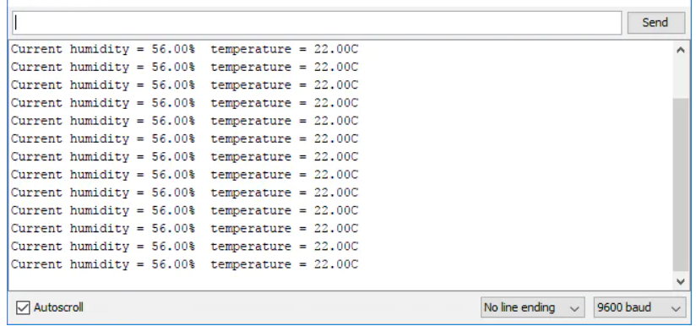

2) CODE:- LIGHT INTENSITY USING LDR

void setup() {

// put your setup code here, to run once:

Serial.begin(9600);

}

void loop() {

// put your main code here, to run repeatedly:

int a=analogRead(15);

Serial.println("ldr value is");

Serial.println(a);

delay(2000);

}

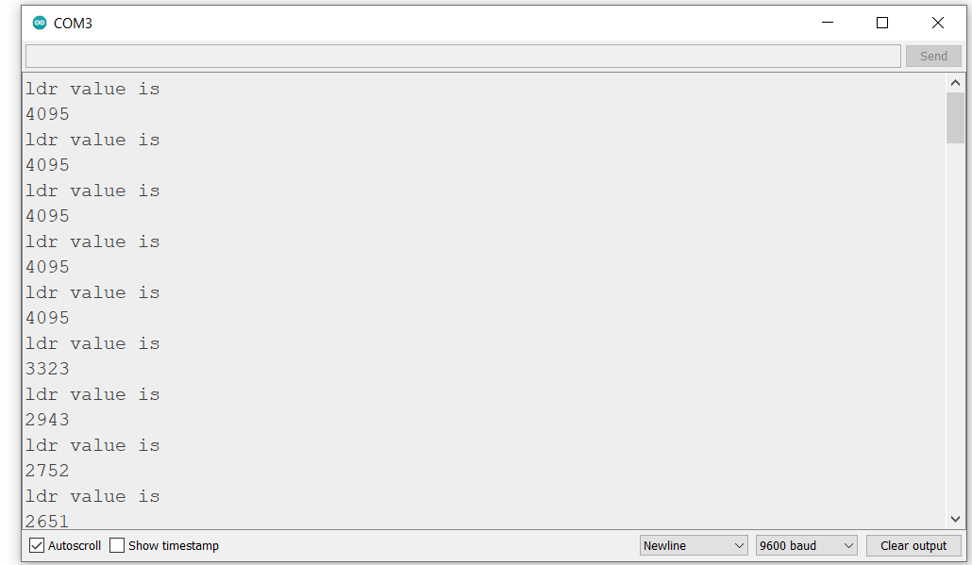

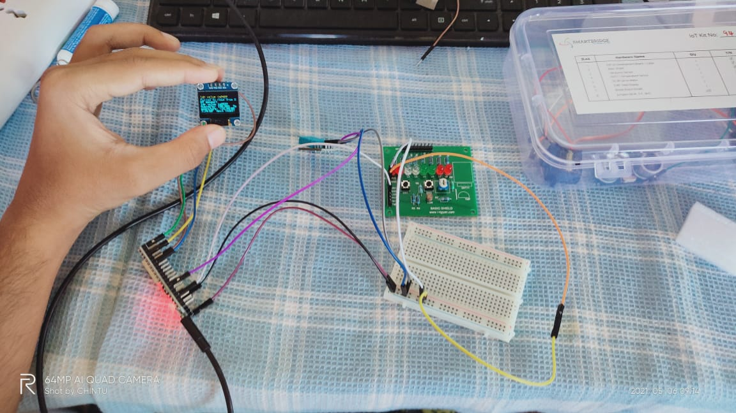

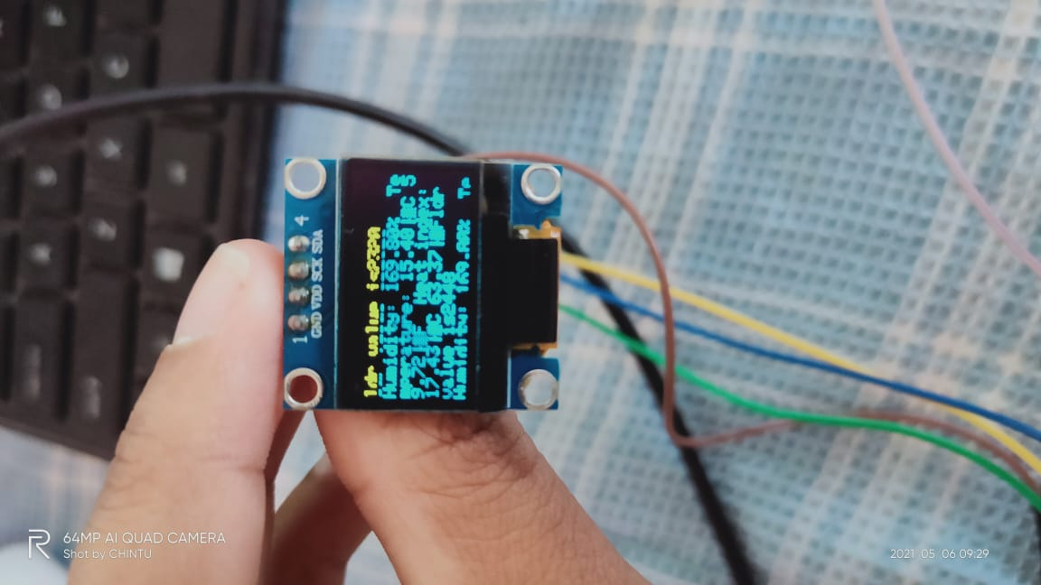

3) DISPLAY LDR VALUES, TEMPERATURE AND HUMIDITY ON OLED

#include <Wire.h>

#include <Adafruit_GFX.h>

#include <Adafruit_SSD1306.h>

#include "DHT.h"

#define SCREEN_WIDTH 128 // OLED display width, in pixels

#define SCREEN_HEIGHT 64 // OLED display height, in pixels

#define DHTPIN 4

#define DHTTYPE DHT11

// Declaration for an SSD1306 display connected to I2C (SDA, SCL pins)

Adafruit_SSD1306 display(SCREEN_WIDTH, SCREEN_HEIGHT, &Wire, -1);

DHT dht(DHTPIN, DHTTYPE);

void setup() {

Serial.begin(115200);

delay(2000);

Serial.println("oled test");

if(!display.begin(SSD1306_SWITCHCAPVCC, 0x3C)) {

Serial.println("SSD1306 allocation failed");

Serial.println(F("DHTxx test!"));

dht.begin();

for(;;);

}

delay(2000);

display.clearDisplay();

display.setTextSize(1);

display.setTextColor(WHITE);

display.setCursor(0, 10);

// Display static text

}

void loop() {

int a=analogRead(15);

display.print("ldr value is");

display.println(a);

delay(5000);

// Reading temperature or humidity takes about 250 milliseconds!

// Sensor readings may also be up to 2 seconds 'old' (its a very slow sensor)

float h = dht.readHumidity();

// Read temperature as Celsius (the default)

float t = dht.readTemperature();

// Read temperature as Fahrenheit (isFahrenheit = true)

float f = dht.readTemperature(true);

// Check if any reads failed and exit early (to try again).

if (isnan(h) || isnan(t) || isnan(f)) {

display.println(F("Failed to read from DHT sensor!"));

return;

}

// Compute heat index in Fahrenheit (the default)

float hif = dht.computeHeatIndex(f, h);

// Compute heat index in Celsius (isFahreheit = false)

float hic = dht.computeHeatIndex(t, h, false);

display.print (F("Humidity: "));

display.print(h);

display.print(F("% Temperature: "));

display.print(t);

display.print(F("°C "));

display.print(f);

display.print(F("°F Heat index: "));

display.print(hic);

display.print(F("°C "));

display.print(hif);

display.print(F("°F"));

display.display();

delay(2000);

}

**4)CONTROL LIGHTS BASED ON LIGHT INTENSITY**

void setup() {

pinMode(4,OUTPUT);

Serial.begin(9600);

}

void loop() {

int ldrval=analogRead(15);

1. //int a=digitalRead(4);

Serial.print("the LDR value is:");

Serial.println(ldrval);

delay(1000);

if(ldrval<=2000)

{

digitalWrite(4,LOW);

Serial.println("led is off");

delay(1000);

}

else

{

digitalWrite(4,HIGH);

Serial.println("led is on");

delay(1000);

}}

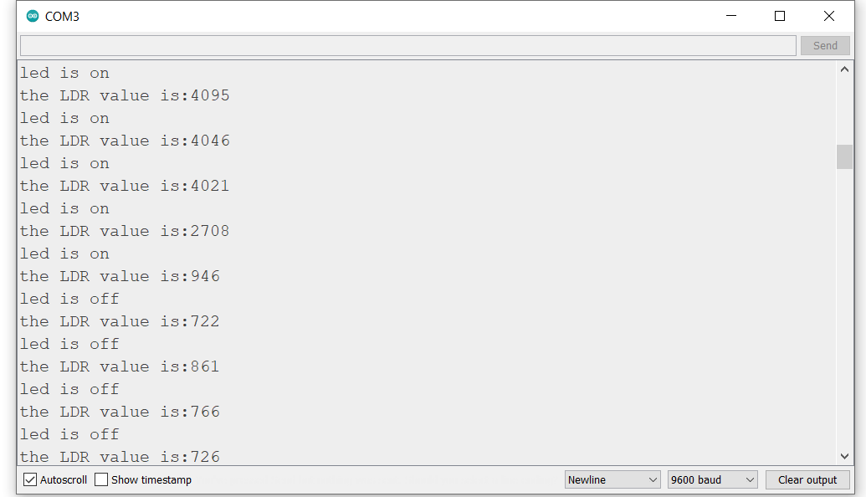

5) CONTROL FANS BASED ON HUMIDITY AND TEMPERATURE.

#include "DHT.h"

#define DHTPIN 4 // Digital pin connected to the DHT sensor

// Feather HUZZAH ESP8266 note: use pins 3, 4, 5, 12, 13 or 14 --

// Pin 15 can work but DHT must be disconnected during program upload.

// Uncomment whatever type you're using!

//#define DHTTYPE DHT11 // DHT 11

#define DHTTYPE DHT11 // DHT 22 (AM2302), AM2321

//#define DHTTYPE DHT21 // DHT 21 (AM2301)

// Connect pin 1 (on the left) of the sensor to +5V

// NOTE: If using a board with 3.3V logic like an Arduino Due connect pin 1

// to 3.3V instead of 5V!

// Connect pin 2 of the sensor to whatever your DHTPIN is

// Connect pin 3 (on the right) of the sensor to GROUND (if your sensor has 3 pins)

// Connect pin 4 (on the right) of the sensor to GROUND and leave the pin 3 EMPTY (if your sensor has 4 pins)

// Connect a 10K resistor from pin 2 (data) to pin 1 (power) of the sensor

// Initialize DHT sensor.

// Note that older versions of this library took an optional third parameter to

// tweak the timings for faster processors. This parameter is no longer needed

// as the current DHT reading algorithm adjusts itself to work on faster procs.

DHT dht(DHTPIN, DHTTYPE);

void setup() {

Serial.begin(9600);

Serial.println(F("DHTxx test!"));

pinMode(2,OUTPUT);

dht.begin();

}

void loop() {

// Wait a few seconds between measurements.

delay(2000);

// Reading temperature or humidity takes about 250 milliseconds!

// Sensor readings may also be up to 2 seconds 'old' (its a very slow sensor)

float h = dht.readHumidity();

// Read temperature as Celsius (the default)

float t = dht.readTemperature();

// Read temperature as Fahrenheit (isFahrenheit = true)

float f = dht.readTemperature(true);

// Check if any reads failed and exit early (to try again).

if (isnan(h) || isnan(t) || isnan(f)) {

Serial.println(F("Failed to read from DHT sensor!"));

return;

}

// Compute heat index in Fahrenheit (the default)

float hif = dht.computeHeatIndex(f, h);

// Compute heat index in Celsius (isFahreheit = false)

float hic = dht.computeHeatIndex(t, h, false);

Serial.print(F("Humidity: "));

Serial.println(h);

Serial.print(F("% Temperature: "));

Serial.println(t);

Serial.print(F("°C "));

Serial.println(f);

Serial.print(F("°F Heat index: "));

Serial.println(hic);

Serial.print(F("°C "));

Serial.print(hif);

Serial.println(F("°F"));

delay(2000);

if((h<=56)&&(t<32.0))

{

digitalWrite(2,LOW);

delay(2000);

Serial.println("fan is off");

}

else

{

digitalWrite(2,HIGH);

delay(2000);

Serial.println("fan is on");

}

}

